 |   Epsilon Kran GmbH  Christophorusstraße 30  A- 5061 Elsbethen |  |  |  |  | A1 Form  Change of Factory Settings |  |  |  |  |  |  |  |  | Address  General Agency / OEM:
 | Loader Type: |  |  | Serial Number: |  |  |  |  |  | Warranty Start Date:
 | 1. Circuit  or LS | Δp [bar] | L/min |  | RPM |  | MAIN CONTROL VALVE | Sealing-  No.: |  |  | Colour: | Pressure  [bar] |  | PUMP |  | Sealing-  No.: | Colour: | Pressure  [bar]
 | 
 | 2. Circuit | Δp [bar] | L/min |  | RPM |  |  | Sealing-  No.: |  |  | Colour: | Pressure  [bar] |  |  |  | Sealing-  No.: | Colour: | Pressure  [bar]
 | 
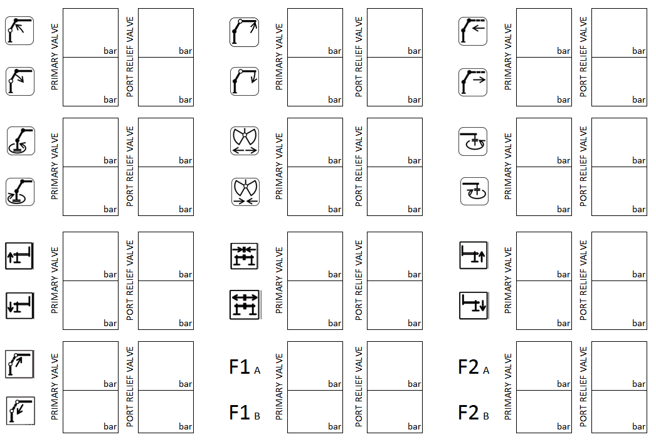

Hydraulicoil:
Standby (Pump), when LS:
Tank (Litere)
 | For load sensing systems:  The loader’s maximum pressure (main pressure) must  be adjusted on the pressure relief valve of the pump ! |  |  |  |  |  |  |  |  |  |  |  | Address, Signature, Stamp  of person who carried out the changes:
 | Adjustments carried out by: |  |  |  |  |  |  |  | Date of adjustments:

